Offer of Archival Materials
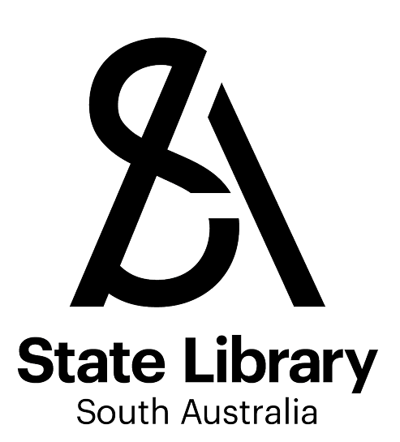
This form collects information about archival materials being offered to the Library. Archival materials include letters, photographs, pictures, minute books, notebooks, diaries and other original or unpublished materials. The Collections Policy and Archival Collections Policy (SLSA6665) detail priorities and exclusions.
Please provide as much information as possible about the materials being offered as this will assist the Library in assessing the material. Please attach photographs of the collection if possible.

Contact Information
Name:

Address:

Phone:
Email:
Date:

Provenance of the Material
What is your relationship to the material?
☐ Creator ☐ Owner ☐ Executor of Estate/Agents of Owners
☐ Employee ☐ Relative ☐ Vendor ☐ Other
Further details (as required):

The Materials on Offer
Creator name (the individual/organisation who created the materials):

Creator information:

Description (why was the material created, what people, events, places, subjects are documented?):

Why are the materials significant?:

Dates:
Format (select applicable): ☐ Manuscript ☐ Pictures ☐ Photographs
☐ Drawings ☐ Printed ☐ Audio ☐ Oral History ☐ Photocopies ☐ Other
Further details:
Digital: ☐ Yes ☐ No
If Yes please specify format: ☐ Text ☐ Image ☐ Moving Image ☐ Audio
☐ Website ☐ Other
Further details:
Quantity (eg. 12 photographs, 10 boxes):
Further details:
Condition: ☐ Good ☐ OK ☐ Poor
Further details:
Location: ☐ Own premises ☐ Storage facility ☐ Other (provide details)
Further details:
Is there an item listing for the material? ☐ Yes (please attach) ☐ No
Any further information (for example, references to relevant research etc.):

Form of Offer
☐ Donation ☐ Purchase ☐ Cultural Gifts donation

Conditions of Offer
If you are considering any conditions upon the offer of the material please state:

Submit form to: SLSA.ArchivalCollections@sa.gov.au

